User Guide:
Salesforce Updates for Marketing Website

Version History
Version | Description of Change | Author | Date
1.0 | Summary of changes made to Salesforce front-end to enable publishing units to the new Grainger marketing website. | Dillan Landsberg, Nikki Papenfus | 30/05/2024
Table of Contents

1. Overview 3
2. Estate / Block Detail Changes 4
3. Building Detail Changes 4
4. Unit Detail Changes 5
5. Publish/Update Listing 6
6. Unit List View 8

Overview
Grainger’s Salesforce implementation has been enhanced to enable units to be published to the new Grainger marketing website.

This user guide summarises the changes that have been made to Salesforce screens.

- Additional information about the estate, building and unit that is displayed on the Grainger website listing, will need to be captured in the following screens:

  - Estate/Block Details
  - Building Details
  - Unit Details

- Publish/Update Listing – This existing process has been enhanced to allow for publishing, updating and removing listings from the Grainger website as well as Rightmove.

- Unit List View – A new list view displays all units with active Grainger Website listings.

Estate / Block Detail Changes
A new field 'Rental Type' has been added to the Block to indicate whether a property is Build to Rent (BTR) or Private Rented Sector (PRS)
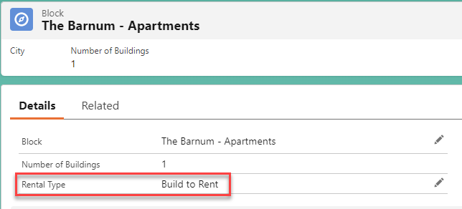

Building Detail Changes
The following changes have been made to Building Details:

- Building Launch Date – A new, optional field that should be entered for new developments.
- Marketing Location – New
- ‘Building Amenities’ have been renamed to Building Features.
  - New features are available for selection.
  - The Pets Friendly checkbox is automatically updated when the ‘Pet Friendly’ feature is selected or removed.
  - The Parking Availability checkbox has been replaced by a new ‘Parking Available’ feature.
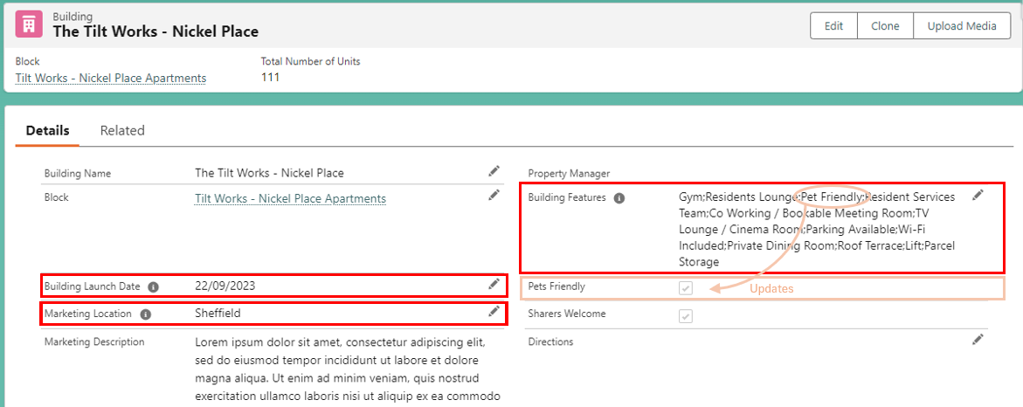

Unit Detail Changes
The following new fields, that will display on the Grainger website listing, have been added to the Unit Details screen:

- Up to four Unique Selling Points may be captured.
- Unit Features may be selected; Building Features are displayed above for reference.
- Discounted Rent Type (Discounted Market Rent or London Living Rent) may be selected where applicable.
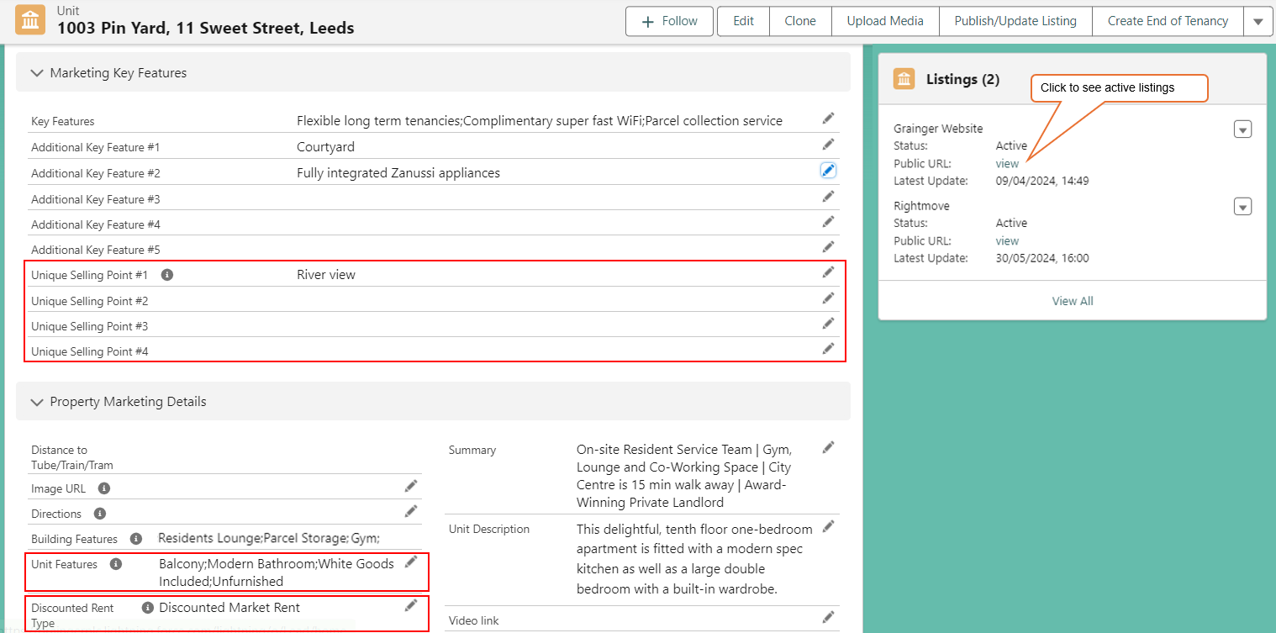

Publish/Update Listing
The existing Publish/Update Listing button on the Unit screen will allow you to publish a unit listing to Rightmove and / or the Grainger website.
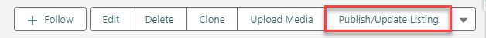

NOTE: All of the information required to list the unit on both Rightmove AND the Grainger website must be captured before the unit can be listed on either site.

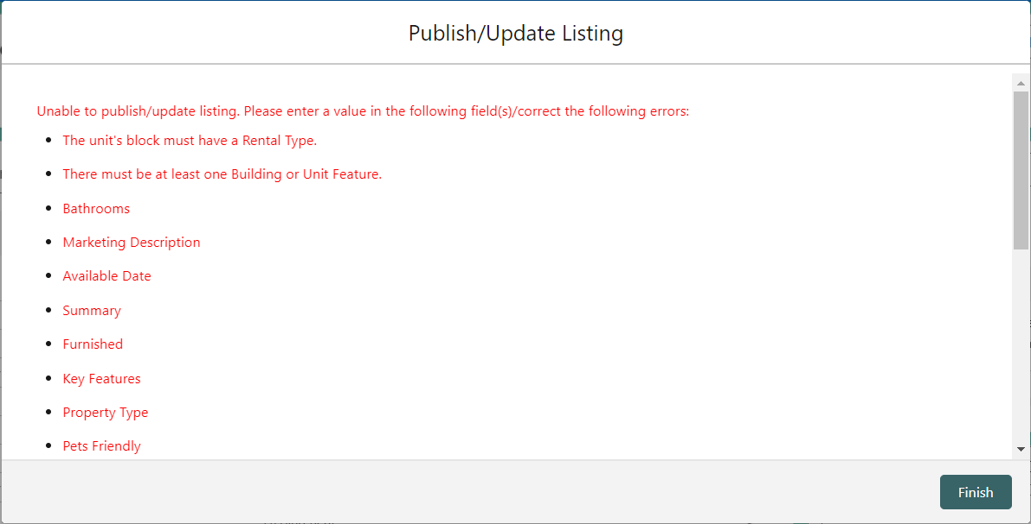
- Additional information is now required before publishing –

  - Estate / block information required:
    - Rental Type
  - Building information required:
    - Marketing Description
    - Marketing Location
  - At least one building feature or unit feature must be selected.
  - Unit information required:
    - District
    - Post Code
    - Internal Space GIA ft² & Internal Space GIA m²
  - Unit media links:
    - Floor plans must be in JPG or PDF format.
    - There must be at least 4 images (in JPG format).
    - An Order Number must be populated for each media link.

You will have a choice of publishing, updating or removing the unit listing on the Grainger Website and/or Rightmove site.

- The updates to the two sites are specified independently. For example, if you want to remove a listing from one site and publish the listing on the other site, select both sites on the screen below.
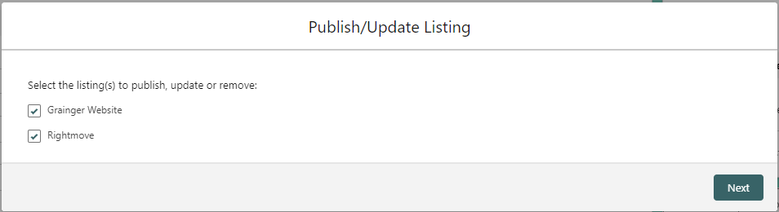
A separate overview of the information relevant to each listing will be displayed for the site(s) selected above. If both are selected, the Grainger listing information will appear first, followed by the Rightmove listing.

- Review the listing information that will be published to the site.
- Select whether to Publish Listing, Update Listing or Remove Listing for that site.
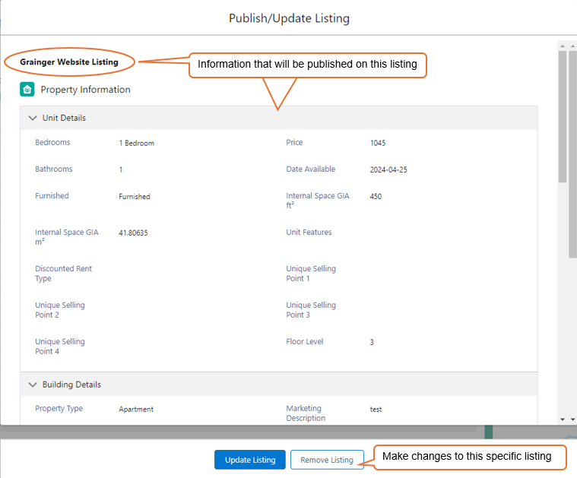

Unit List View
A new list of Grainger Website Listings displays all units that are currently listed on the Grainger website.
